Weinor Frame Colours

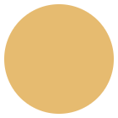

RAL 1002  
Sand yellow

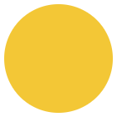

RAL 1003  
Signal yellow

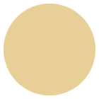

RAL 1014  
Ivory

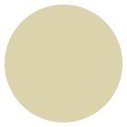

RAL 1015  
Light Ivory

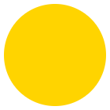

RAL 1023  
Traffic yellow

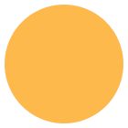

RAL 1034  
Pastel yellow

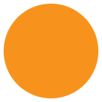

RAL 2000  
Yellow orange

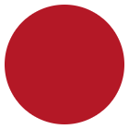

RAL 2002  
Vermillion

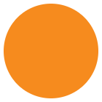

RAL 2011  
Deep orange

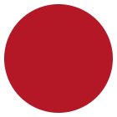

RAL 3002  
Carmine red

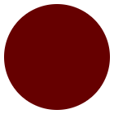

RAL 3004  
Magenta red

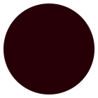

RAL 3007  
Black red

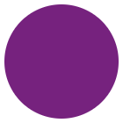

RAL 4005  
Blue Illac

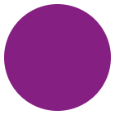

RAL 4006  
Traffic purple

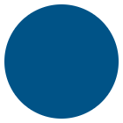

RAL 5005  
Signal blue

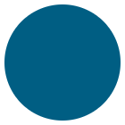

RAL 5009  
Azure blue

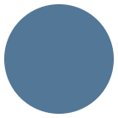

RAL 5014  
Pigeon blue

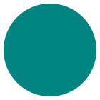

RAL 5021  
Water blue

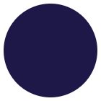

RAL 5022  
Night blue

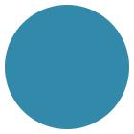

RAL 5024  
Pastel blue

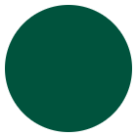

RAL 6005  
Moss green

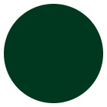

RAL 6009  
Fir green

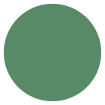

RAL 6011  
Reseda green

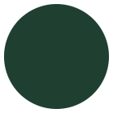

RAL 6012  
Black green

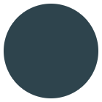

RAL 7015  
Slate grey

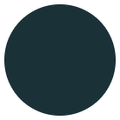

RAL 7016  
Anthracite grey

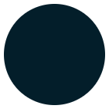

RAL 7021  
Black grey

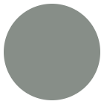

RAL 7030  
Stone grey

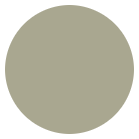

RAL 7032  
Pebble grey

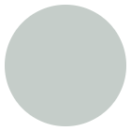

RAL 7035  
Light grey

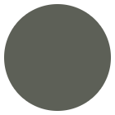

RAL 7039  
Quartz grey

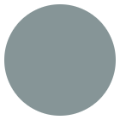

RAL 7040  
Window grey

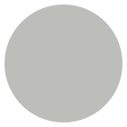

RAL 7319  
Weinor grey

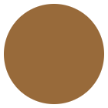

RAL 8001  
Ochre brown

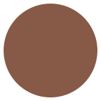

RAL 2002  
Clay brown

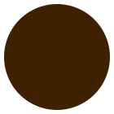

RAL 8014  
Sepia brown

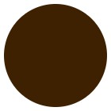

RAL 8016  
Mahagony brown

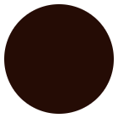

RAL 8017  
Chocolate brown

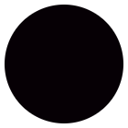

RAL 8019  
Grey brown

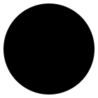

RAL 8022  
Black brown

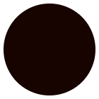

RAL 8077  
Weinor dark brown

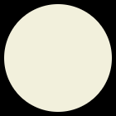

RAL 9001  
Creme

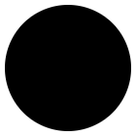

RAL 9005  
Jetblack

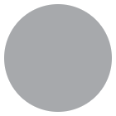

RAL 9006  
White aluminium

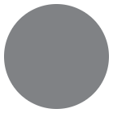

RAL 9007  
Grey aluminium

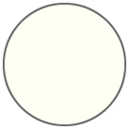

RAL 9010  
Pure white

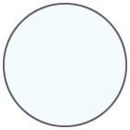

RAL 9016  
Traffic white

**Trend colours**

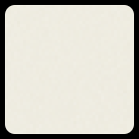

WT 029/10797  
Approx. RAL 9010

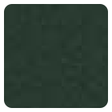

WT 029/50704  
Approx RAL 6009 Metallic

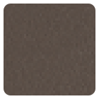

WT 029/60740  
Marrone 04 Metallic

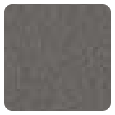

WT 029/70786  
Sparkling Iron Effect

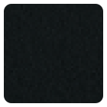

WT 029/71289  
Approx. RAL 7016 Metallic

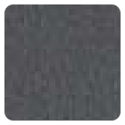

WT 029/80077  
Approx. DB 703 Mettalic

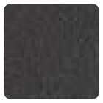

WT 029/80081  
Iron Glimmer Effect P7

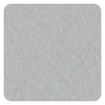

WT 029/90146  
Approx. RAL 9006 Metallic

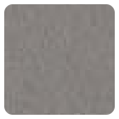

WT 029/90147  
Approx. RAL 9007 Metallic