[](https://www.weinor.com/fabric-and-co/world-of-fabrics/special-collections/details/d/s/screens-by-weinor/7-108/?cHash=b09abdc703bd899aacad0259793da94f)

7-108

[](https://www.weinor.com/fabric-and-co/world-of-fabrics/special-collections/details/d/s/screens-by-weinor/7-109/?cHash=8826dfba4c9abf273d53a1b2e17ecff8)

7-109

[](https://www.weinor.com/fabric-and-co/world-of-fabrics/special-collections/details/d/s/screens-by-weinor/7-106/?cHash=10788fe73883abae5c8c692f3eb4e2fb)

7-106

[](https://www.weinor.com/fabric-and-co/world-of-fabrics/special-collections/details/d/s/screens-by-weinor/7-110/?cHash=19e2631144f9f0e80b0c20cc92edb807)

7-110

[](https://www.weinor.com/fabric-and-co/world-of-fabrics/special-collections/details/d/s/screens-by-weinor/7-103/?cHash=893de7979aa76640734cf66ebd47d97d)

7-103

[](https://www.weinor.com/fabric-and-co/world-of-fabrics/special-collections/details/d/s/screens-by-weinor/7-105/?cHash=5df98be838c46feeaf49be2b504622d5)

7-105

[](https://www.weinor.com/fabric-and-co/world-of-fabrics/special-collections/details/d/s/screens-by-weinor/7-104/?cHash=fe4925dc1121ec7e2607d59a66eb2c5f)

7-104

[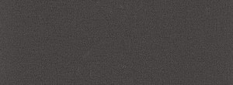](https://www.weinor.com/fabric-and-co/world-of-fabrics/special-collections/details/d/s/screens-by-weinor/7-111/?cHash=bafd99a825fe5cbca07b0292d7afcf6a)

7-111

[](https://www.weinor.com/fabric-and-co/world-of-fabrics/special-collections/details/d/s/screens-by-weinor/7-107/?cHash=70cf9bacff9468d6d041d44e85878e0f)

7-107

[](https://www.weinor.com/fabric-and-co/world-of-fabrics/special-collections/details/d/s/screens-by-weinor/7-100/?cHash=b8e3c23b1e99ded8c764b7221b4c9340)

7-100 (Melange)

[](https://www.weinor.com/fabric-and-co/world-of-fabrics/special-collections/details/d/s/screens-by-weinor/7-101/?cHash=3be08e0346d6b8536cfb96b5400144f0)

7-101 (Melange)

[](https://www.weinor.com/fabric-and-co/world-of-fabrics/special-collections/details/d/s/screens-by-weinor/7-102/?cHash=f3a1274840ced595864497cffdccda0e)

7-102 (Melange)

[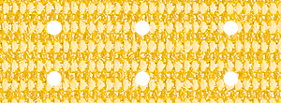](https://www.weinor.com/fabric-and-co/world-of-fabrics/special-collections/details/d/s/screens-by-weinor/3-502p-1/?cHash=1c7db9d24807d5c0b303ad1b2f3a7798)

3-502P

[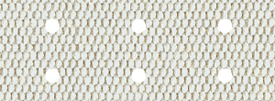](https://www.weinor.com/fabric-and-co/world-of-fabrics/special-collections/details/d/s/screens-by-weinor/3-708p/?cHash=fc7bd7c829d6ff5e086111046dc5fc66)

3-708P

[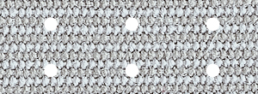](https://www.weinor.com/fabric-and-co/world-of-fabrics/special-collections/details/d/s/screens-by-weinor/3-509p-1/?cHash=1608ad77b57a4d007be51c25969f8ddb)

3-509P

[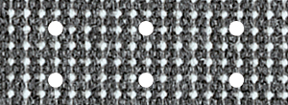](https://www.weinor.com/fabric-and-co/world-of-fabrics/special-collections/details/d/s/screens-by-weinor/3-720p/?cHash=e16576dca0a26dbf18d38a73212e4b5a)

3-720P

[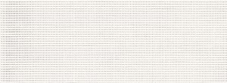](https://www.weinor.com/fabric-and-co/world-of-fabrics/special-collections/details/d/s/screens-by-weinor/86-2044/?cHash=017be8450b681a3e6ecc01350e54c6a8)

86-2044

[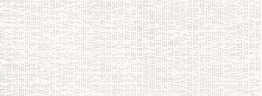](https://www.weinor.com/fabric-and-co/world-of-fabrics/special-collections/details/d/s/screens-by-weinor/92-2044/?cHash=a504dd8474cf9fde8b6aee3f85595aa6)

92-2044

[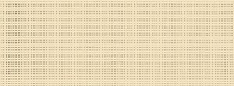](https://www.weinor.com/fabric-and-co/world-of-fabrics/special-collections/details/d/s/screens-by-weinor/86-2175/?cHash=46e3b1e1b43f98dcc53e1c91592b99e2)

86-2175

[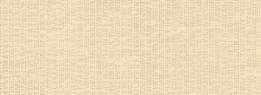](https://www.weinor.com/fabric-and-co/world-of-fabrics/special-collections/details/d/s/screens-by-weinor/92-2175/?cHash=b280106d19bf09096662f223ee860eec)

92-2175

[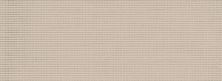](https://www.weinor.com/fabric-and-co/world-of-fabrics/special-collections/details/d/s/screens-by-weinor/86-2135/?cHash=31105f8b5c7d9c19b2b8b1922d40ba09)

86-2135

[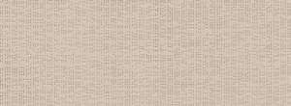](https://www.weinor.com/fabric-and-co/world-of-fabrics/special-collections/details/d/s/screens-by-weinor/92-2135/?cHash=4bda08e9e49f429b7767543c6c5a55fb)

92-2135

[](https://www.weinor.com/fabric-and-co/world-of-fabrics/special-collections/details/d/s/screens-by-weinor/86-2166/?cHash=afc3ad5f190005fea1917287778da8e8)

86-2166

[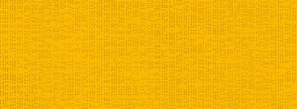](https://www.weinor.com/fabric-and-co/world-of-fabrics/special-collections/details/d/s/screens-by-weinor/92-2166/?cHash=1a110806e7a5503d0180f9fff6b8a1b5)

92-2166

[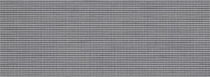](https://www.weinor.com/fabric-and-co/world-of-fabrics/special-collections/details/d/s/screens-by-weinor/86-2045/?cHash=42156b4580d00ff090fda84e4d8acb19)

86-2045

[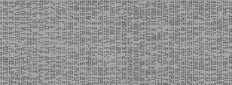](https://www.weinor.com/fabric-and-co/world-of-fabrics/special-collections/details/d/s/screens-by-weinor/92-2045/?cHash=514b465d2f8fc15b888da4dde7d89799)

92-2045

[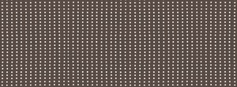](https://www.weinor.com/fabric-and-co/world-of-fabrics/special-collections/details/d/s/screens-by-weinor/86-2043/?cHash=0d0d7e8480cefce2ffc57279ebac9c33)

86-2043

[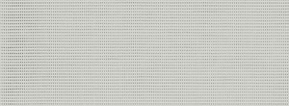](https://www.weinor.com/fabric-and-co/world-of-fabrics/special-collections/details/d/s/screens-by-weinor/86-2171/?cHash=2a3eb900013f85bcb359da4c57c69fde)

86-2171

[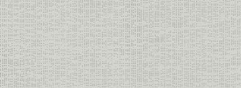](https://www.weinor.com/fabric-and-co/world-of-fabrics/special-collections/details/d/s/screens-by-weinor/92-2171/?cHash=c4ad91f946fff09f73d4e6bc7117d65a)

92-2171

[](https://www.weinor.com/fabric-and-co/world-of-fabrics/special-collections/details/d/s/screens-by-weinor/86-2167/?cHash=8502fe450276a9435525f0124c26e5ce)

86-2167

[](https://www.weinor.com/fabric-and-co/world-of-fabrics/special-collections/details/d/s/screens-by-weinor/92-2167/?cHash=6717123a80785cd01889a87f64c41d27)

92-2167

[](https://www.weinor.com/fabric-and-co/world-of-fabrics/special-collections/details/d/s/screens-by-weinor/86-2047/?cHash=1923ad7cb4a8393b76a3a33456cc7d30)

86-2047

[](https://www.weinor.com/fabric-and-co/world-of-fabrics/special-collections/details/d/s/screens-by-weinor/92-2047/?cHash=5e241e69f321b0f98bd36fe8de664999)

92-2047

[](https://www.weinor.com/fabric-and-co/world-of-fabrics/special-collections/details/d/s/screens-by-weinor/86-2046-reverse-side-white/?cHash=094621944bab0f1bcc8955d33948e58c)

86-2046 (BiColour)

[](https://www.weinor.com/fabric-and-co/world-of-fabrics/special-collections/details/d/s/screens-by-weinor/92-2046-reverse-side-white/?cHash=d0c4952a4ba34c98b1ed66dd5b457036)

92-2046 (BiColour)

[](https://www.weinor.com/fabric-and-co/world-of-fabrics/special-collections/details/d/s/screens-by-weinor/86-2048-2/?cHash=1b4f76e4a92ecb697b2eec424ce5e8b0)

86-2048 (BiColour)

[](https://www.weinor.com/fabric-and-co/world-of-fabrics/special-collections/details/d/s/screens-by-weinor/92-2048/?cHash=f0a4cea7f1dbabb9eb4f4513e1b436ce)

92-2048 (BiColour)

[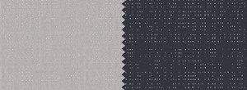](https://www.weinor.com/fabric-and-co/world-of-fabrics/special-collections/details/d/s/screens-by-weinor/92-2068/?cHash=cb1763372667ede455a68bf25f487827)

92-2068 (BiColour)

[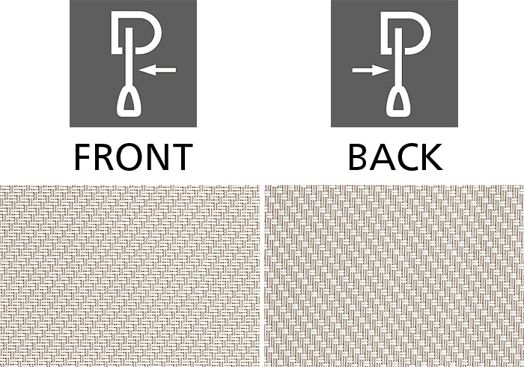](https://www.weinor.com/fabric-and-co/world-of-fabrics/special-collections/details/d/s/screens-by-weinor/glasfaser-test-1/?cHash=6456da22a42848a4e708e6f9a6d456db)

7-201

[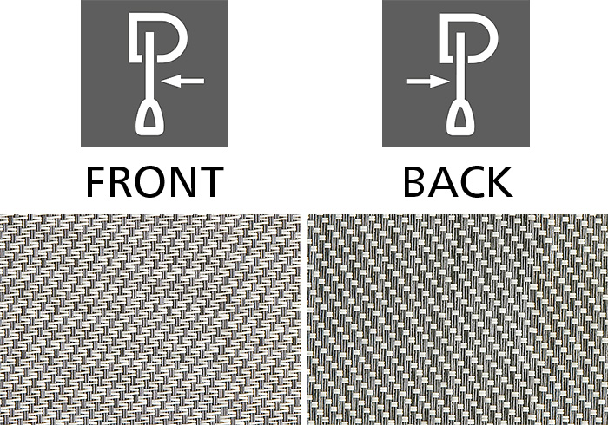](https://www.weinor.com/fabric-and-co/world-of-fabrics/special-collections/details/d/s/screens-by-weinor/7-202/?cHash=d8fe66cef3e08b5514bdc8f33c1e9b3a)

7-202

[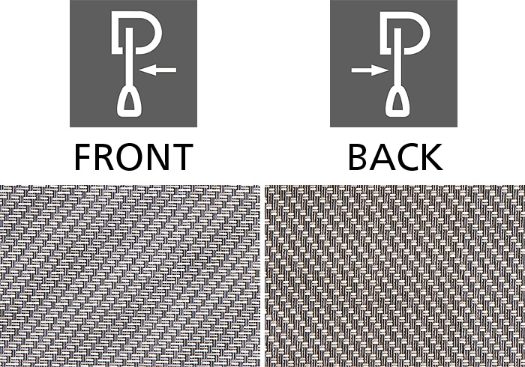](https://www.weinor.com/fabric-and-co/world-of-fabrics/special-collections/details/d/s/screens-by-weinor/7-203/?cHash=6df7918b619cf3b119f1c6cec43cd1a3)

7-203

[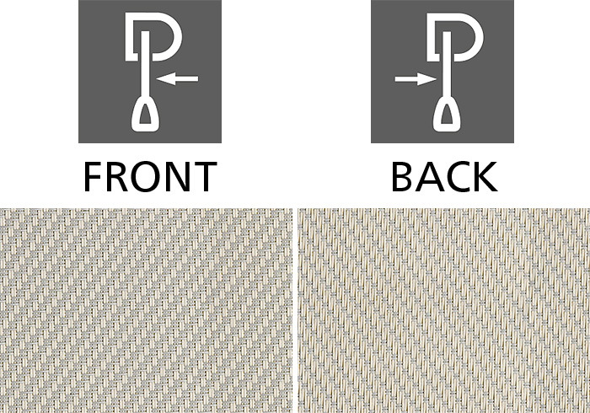](https://www.weinor.com/fabric-and-co/world-of-fabrics/special-collections/details/d/s/screens-by-weinor/7-204/?cHash=ee08d29eb4c6d3be17c493afbacd3360)

7-204

[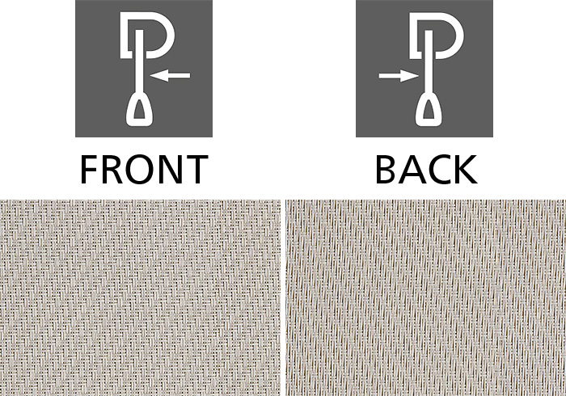](https://www.weinor.com/fabric-and-co/world-of-fabrics/special-collections/details/d/s/screens-by-weinor/7-205/?cHash=549bd6004f9d897d63587ca0cad8a399)

7-205

[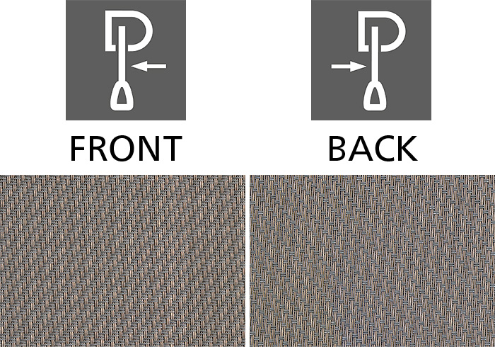](https://www.weinor.com/fabric-and-co/world-of-fabrics/special-collections/details/d/s/screens-by-weinor/7-206/?cHash=b5bd274d61ef7c335dd515435df639e7)

7-206

[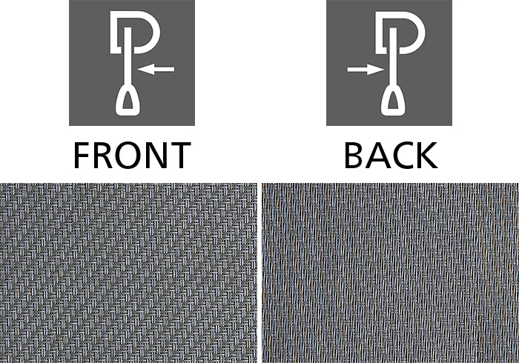](https://www.weinor.com/fabric-and-co/world-of-fabrics/special-collections/details/d/s/screens-by-weinor/7-201/?cHash=e6d7273139a18e04f44b0be81799ded7)

7-207

[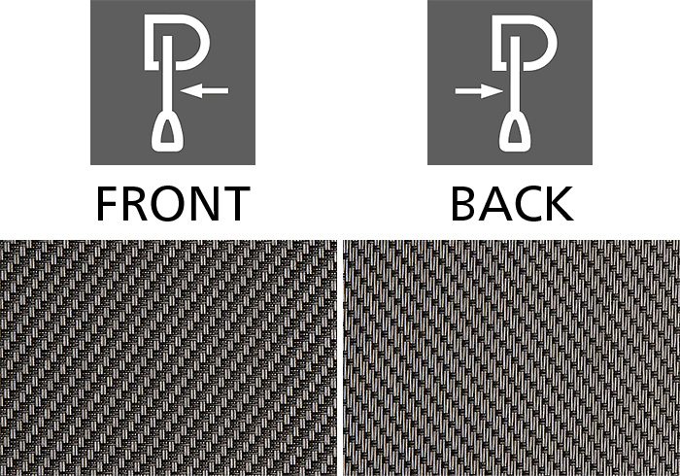](https://www.weinor.com/fabric-and-co/world-of-fabrics/special-collections/details/d/s/screens-by-weinor/7-208/?cHash=2bac8e7c780d537fa4aa340591d579c5)

7-208

[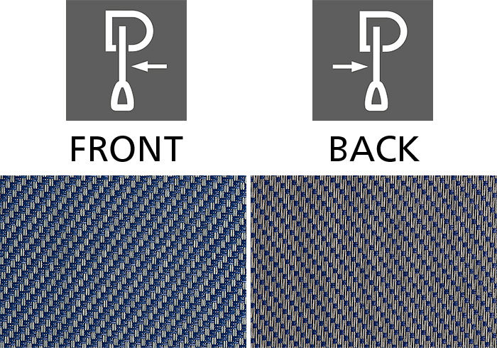](https://www.weinor.com/fabric-and-co/world-of-fabrics/special-collections/details/d/s/screens-by-weinor/7-209/?cHash=6b4f9a5b44cd015f48ca5d335e559d3c)

7-209

[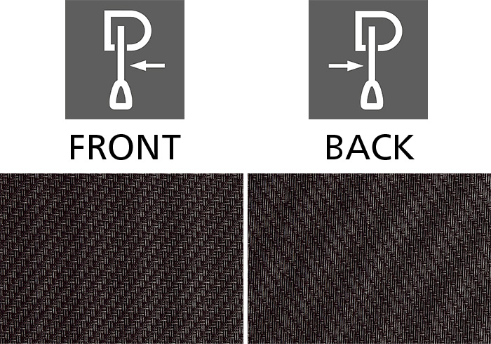](https://www.weinor.com/fabric-and-co/world-of-fabrics/special-collections/details/d/s/screens-by-weinor/7-210/?cHash=04025f57fb49be98e2ae62086f4561d5)

7-210

[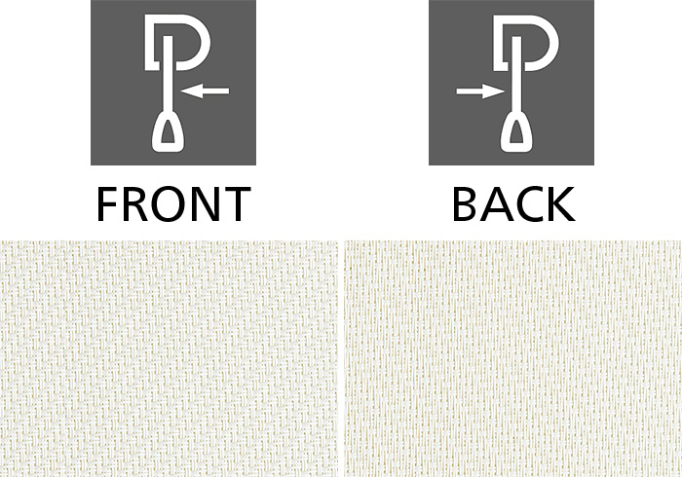](https://www.weinor.com/fabric-and-co/world-of-fabrics/special-collections/details/d/s/screens-by-weinor/7-211/?cHash=8966cfada109fd98445f682e60290565)

7-211

[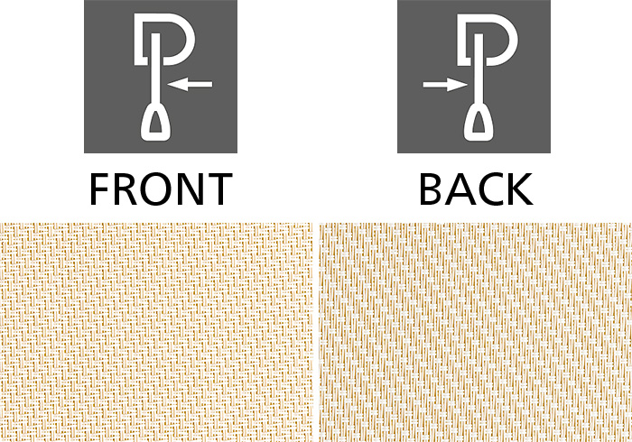](https://www.weinor.com/fabric-and-co/world-of-fabrics/special-collections/details/d/s/screens-by-weinor/7-212/?cHash=9b1d9fbceec6e201e6b323e02f597631)

7-212

[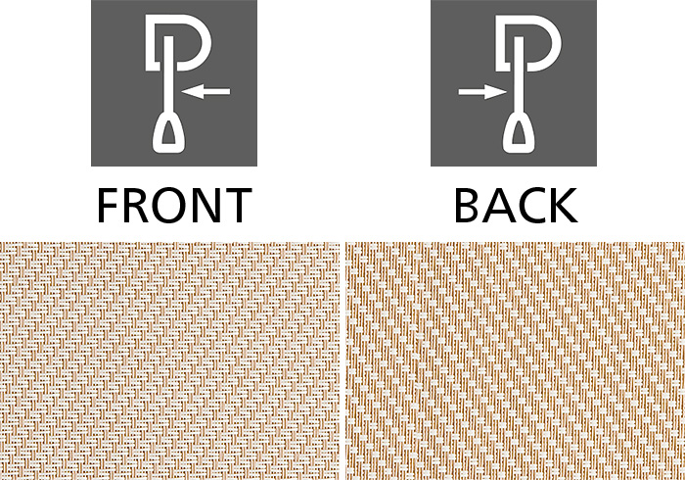](https://www.weinor.com/fabric-and-co/world-of-fabrics/special-collections/details/d/s/screens-by-weinor/7-213/?cHash=932f3c371bf221a08bef42d8d89967bb)

7-213

[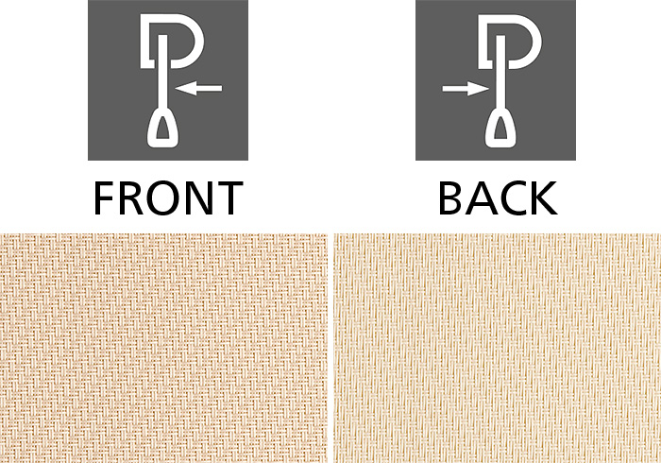](https://www.weinor.com/fabric-and-co/world-of-fabrics/special-collections/details/d/s/screens-by-weinor/7-214/?cHash=63231309994a7f5f0a223d6c3ba6e973)

7-214

[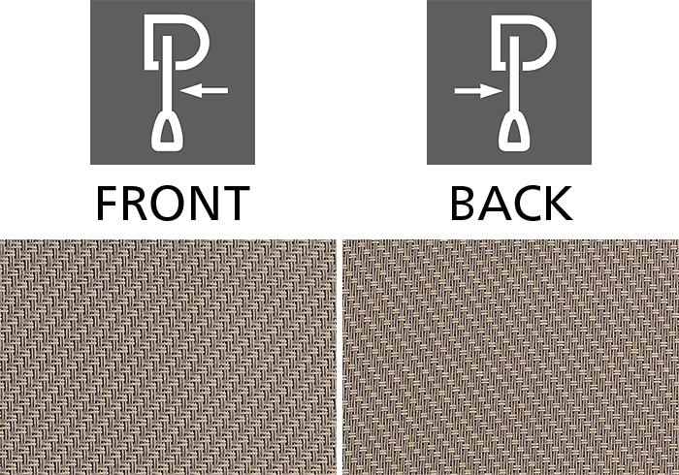](https://www.weinor.com/fabric-and-co/world-of-fabrics/special-collections/details/d/s/screens-by-weinor/7-215/?cHash=eac718ee8a14bb247e7e04bb75670cef)

7-215

[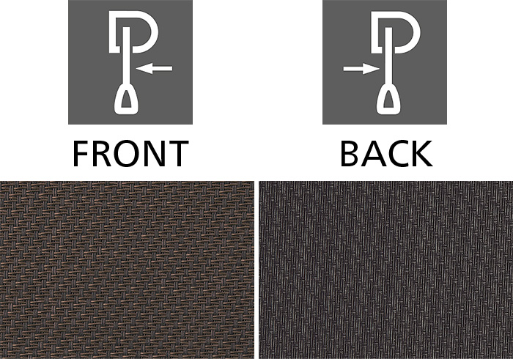](https://www.weinor.com/fabric-and-co/world-of-fabrics/special-collections/details/d/s/screens-by-weinor/7-216/?cHash=190dd21f2584dac85b29d092ac561fa9)

7-216

[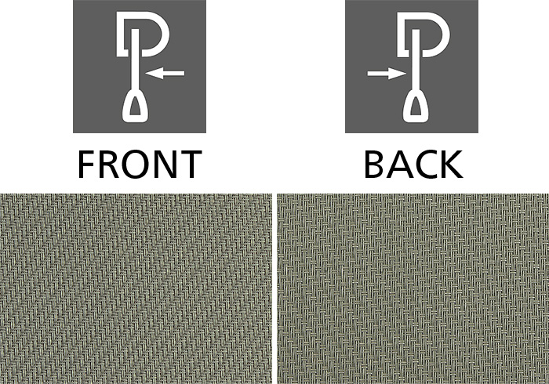](https://www.weinor.com/fabric-and-co/world-of-fabrics/special-collections/details/d/s/screens-by-weinor/7-217/?cHash=74500569a6b5df38eea662e4f05d4f04)

7-217

[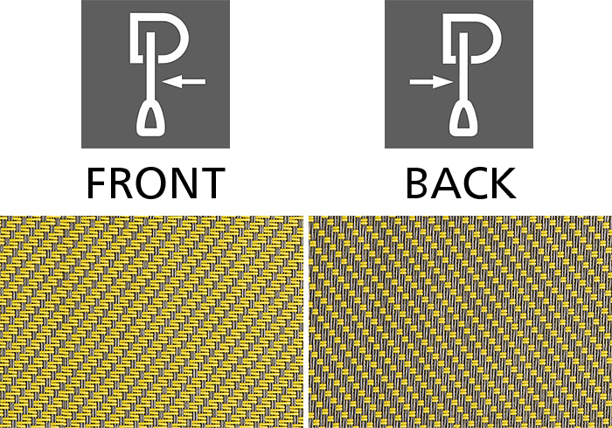](https://www.weinor.com/fabric-and-co/world-of-fabrics/special-collections/details/d/s/screens-by-weinor/7-218/?cHash=1c4e710dfd5a44fb5ef8fa9b26cb29f6)

7-218

[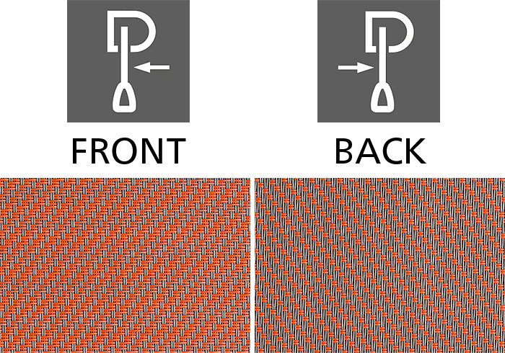](https://www.weinor.com/fabric-and-co/world-of-fabrics/special-collections/details/d/s/screens-by-weinor/7-219/?cHash=c2a9b0af0b6b88a0f86bcf22e2619269)

7-219

[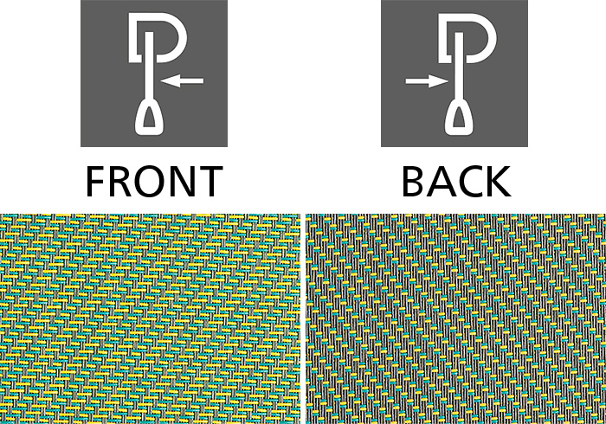](https://www.weinor.com/fabric-and-co/world-of-fabrics/special-collections/details/d/s/screens-by-weinor/7-220/?cHash=fae87cfcf5c2abcffbe608cb8f1afbac)

7-220

[](https://www.weinor.com/fabric-and-co/world-of-fabrics/special-collections/details/d/s/pergona/new-pe-90w/?cHash=8b9bca932d54f23e123ca31ccbb11009)

NEW PE 90W

[](https://www.weinor.com/fabric-and-co/world-of-fabrics/special-collections/details/d/s/pergona/new-pe-100w/?cHash=d7b88a3d14b19e1880a531c45a8c2187)

NEW PE 100W

[](https://www.weinor.com/fabric-and-co/world-of-fabrics/special-collections/details/d/s/pergona/new-pe-110w/?cHash=e08e5dc5bef43183a2910412f86779b3)

NEW PE 110W

[](https://www.weinor.com/fabric-and-co/world-of-fabrics/special-collections/details/d/s/pergona/new-pe-120w/?cHash=b2981e7e3dbc92719e2b67c4c9ab3f5e)

NEW PE 120W

[](https://www.weinor.com/fabric-and-co/world-of-fabrics/special-collections/details/d/s/pergona/new-pe-130w/?cHash=1746aef6ac1f164e82029f38ed96ca97)

NEW PE 130W

[](https://www.weinor.com/fabric-and-co/world-of-fabrics/special-collections/details/d/s/pergona/fe-502-2168/?cHash=88cd6ce21b8c16da327570f15076e388)

PE 10

[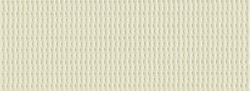](https://www.weinor.com/fabric-and-co/world-of-fabrics/special-collections/details/d/s/pergona/pe-10/?cHash=0e1a47e638fadb0067e63e98457d84da)

PE 20

[](https://www.weinor.com/fabric-and-co/world-of-fabrics/special-collections/details/d/s/pergona/pe-30/?cHash=adcb6d97e2bf2eb23243ef352e8fec0e)

PE 30

[](https://www.weinor.com/fabric-and-co/world-of-fabrics/special-collections/details/d/s/pergona/pe-40/?cHash=ab0a878bf97b4929f32f6324aff7c48b)

PE 40

[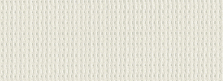](https://www.weinor.com/fabric-and-co/world-of-fabrics/special-collections/details/d/s/pergona/pe-10-1/?cHash=58dc540e28ffa608b4d90a4719afb7e2)

PE 50

[](https://www.weinor.com/fabric-and-co/world-of-fabrics/special-collections/details/d/s/pergona/pe-10-2/?cHash=c413e5763a4e4d7bbdc66ced396defd6)

PE 60

[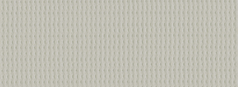](https://www.weinor.com/fabric-and-co/world-of-fabrics/special-collections/details/d/s/pergona/pe-70/?cHash=2c20ac3a4f08679a7c7b3d5fa59faa21)

PE 70

[](https://www.weinor.com/fabric-and-co/world-of-fabrics/special-collections/details/d/s/pergona/pe-80/?cHash=18b5bccb9a65edc6f101b063c34c8aaf)

PE 80

[](https://www.weinor.com/fabric-and-co/world-of-fabrics/special-collections/details/d/s/pergona/na78410/?cHash=d5e5d6f70bee1d2284330aac623c4a69)

PE 140

[](https://www.weinor.com/fabric-and-co/world-of-fabrics/special-collections/details/d/s/pergona/na78683/?cHash=4b74b6c889a3fadbb160f09eeccbe2c2)

PE 150

[](https://www.weinor.com/fabric-and-co/world-of-fabrics/special-collections/details/d/s/pergona/fe502-1013/?cHash=79c67adbaf5757c1722384ea386d7a66)

PE 160

[](https://www.weinor.com/fabric-and-co/world-of-fabrics/special-collections/details/d/s/pergona/fe502-2150/?cHash=5cfc2ab7a255322c2f1a3f6bff5749ef)

PE 170

[](https://www.weinor.com/fabric-and-co/world-of-fabrics/special-collections/details/d/s/livia/1-001/?cHash=0c9593d8b28cc7954335200e883bf574)

WE 1-001

[](https://www.weinor.com/fabric-and-co/world-of-fabrics/special-collections/details/d/s/livia/1-002/?cHash=48dd189b838f8534b709df33653af268)

WE 1-002

[](https://www.weinor.com/fabric-and-co/world-of-fabrics/special-collections/details/d/s/livia/1-003/?cHash=87a9e2e7c85a37dc15535c8fa3c3f74d)

WE 1-003

[](https://www.weinor.com/fabric-and-co/world-of-fabrics/special-collections/details/d/s/livia/1-101/?cHash=0db25ecf0d9e5f16ed46488dd83598e5)

WE 1-101

[](https://www.weinor.com/fabric-and-co/world-of-fabrics/special-collections/details/d/s/livia/1-102/?cHash=bad3d50b000ec772b0bfcf83db591684)

WE 1-102

[](https://www.weinor.com/fabric-and-co/world-of-fabrics/special-collections/details/d/s/livia/1-103/?cHash=53fc3a20bac70e7e76068e6e66cecbf4)

WE 1-103

[](https://www.weinor.com/fabric-and-co/world-of-fabrics/special-collections/details/d/s/livia/1-104/?cHash=26944891dd0b6728bfcd350b9ef32895)

WE 1-104

[](https://www.weinor.com/fabric-and-co/world-of-fabrics/special-collections/details/d/s/livia/1-105/?cHash=bcbb36874f578f3ad4696b2bbaf1da40)

WE 1-105

[](https://www.weinor.com/fabric-and-co/world-of-fabrics/special-collections/details/d/s/livia/1-106/?cHash=f6191bae581514cf2b436a868e3f4a3d)

WE 1-106